BUCK CONVERTER
Introduction:
A buck converter is a DC-to-DC power converter which steps down voltage while stepping up current from its input supply to output load. It typically consists of a switching transistor like mosfet, together with a flywheel circuit composed of a diode, either a capacitor or an inductor for energy storage or both of them in a combination. Buck converters provide much greater efficiency as DC-to-DC converters than linear regulators, which are much simpler circuits that lower voltages by dissipating power as heat but do not step up output current.

Working:
When the transistor is switched on, current flows through the load via the inductor. The inductor opposes changes in the current flow and stores the energy. The output of the switching transistor is prevented from increasing immediately to its peak value as the inductor stores energy taken from the increasing output. This stored energy is later released back into the circuit as back emf as current from the switching transistor is rapidly switched off. When the switching transistor is on, current is flowing through the load via the inductor.

Applications: Buck convertors can be used in brushless DC motor controllers, power audio amplifiers, battery chargers, POL converters etc.

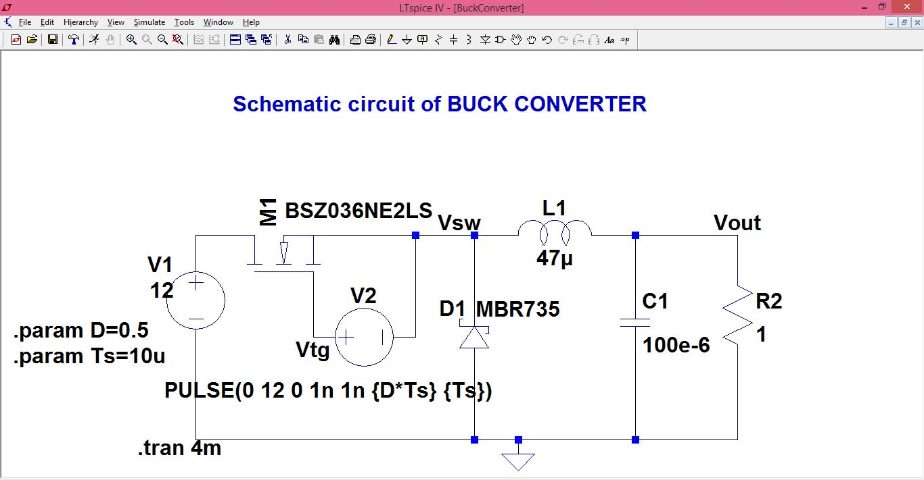
Fig1.

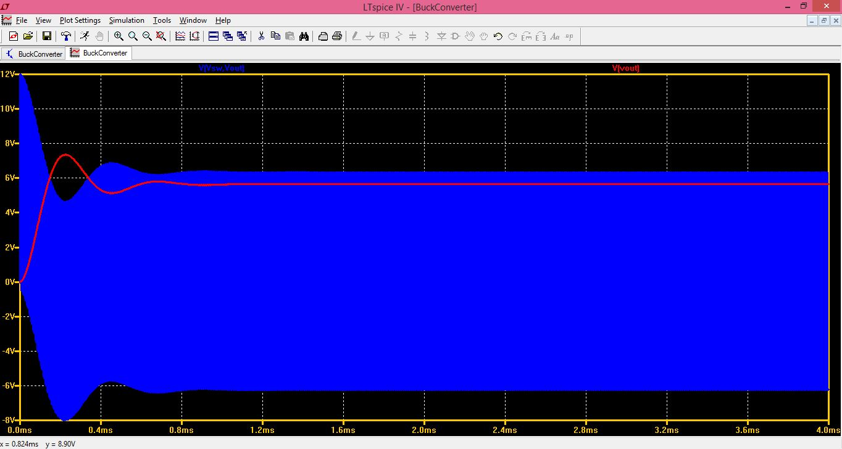
Fig2.

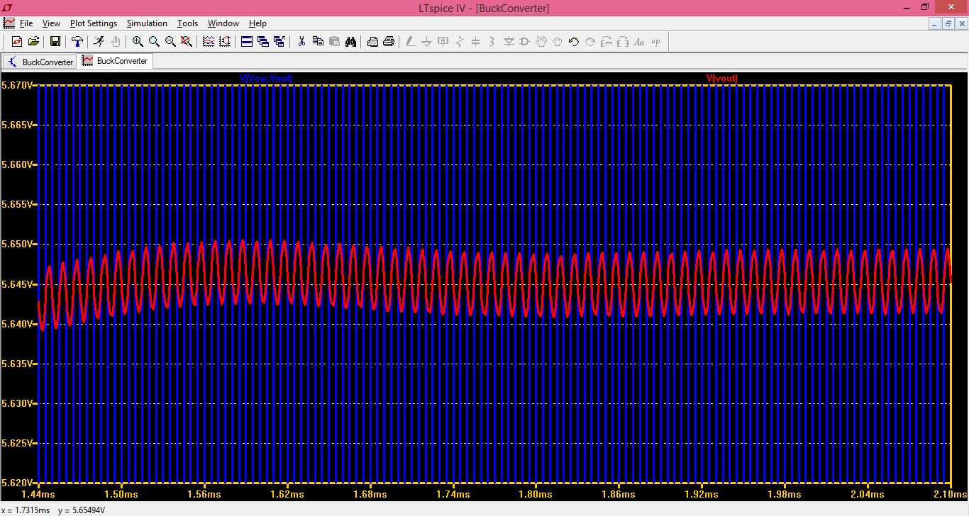
Fig3.
Schematic and Simulation working:
From the schematic Fig1. We can calculate voltage w.r.t ground by clicking on the desired node, or voltage reference across a component by clicking on the first node and dragging the pointer and hovering over the second node. Fig2. and Fig3. Are the simulation results of Fig1. Schematic where in the former, the voltage at the output and the voltage across the inductor is displayed. In Fig.4 the waveform of average power between the diode is displayed by long pressing Alt and hovering over the diode. To find the magnitude of the instantaneous power across the time period, long press Alt+Ctrl and hover over the desired parameter in the simulation window, followed by which the desired parameters will be displayed.

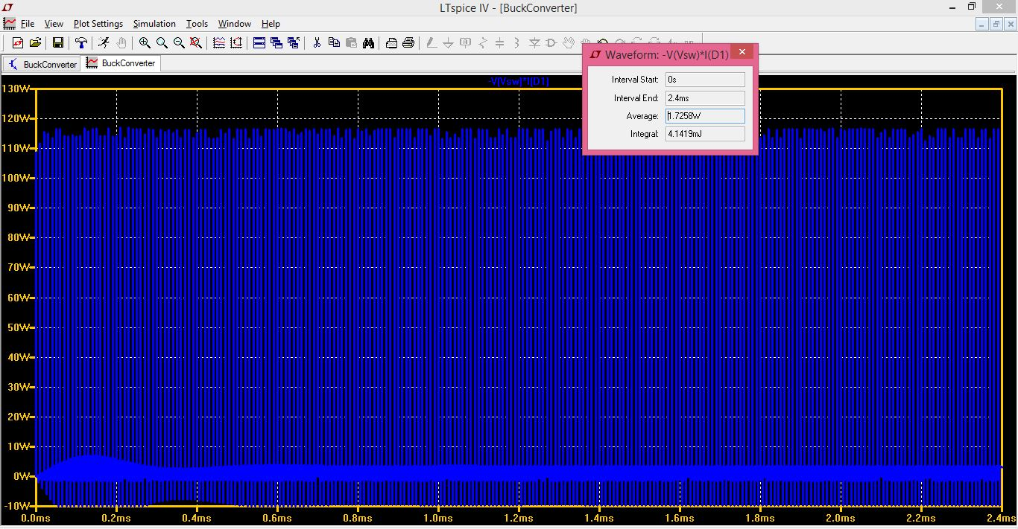
Fig.4
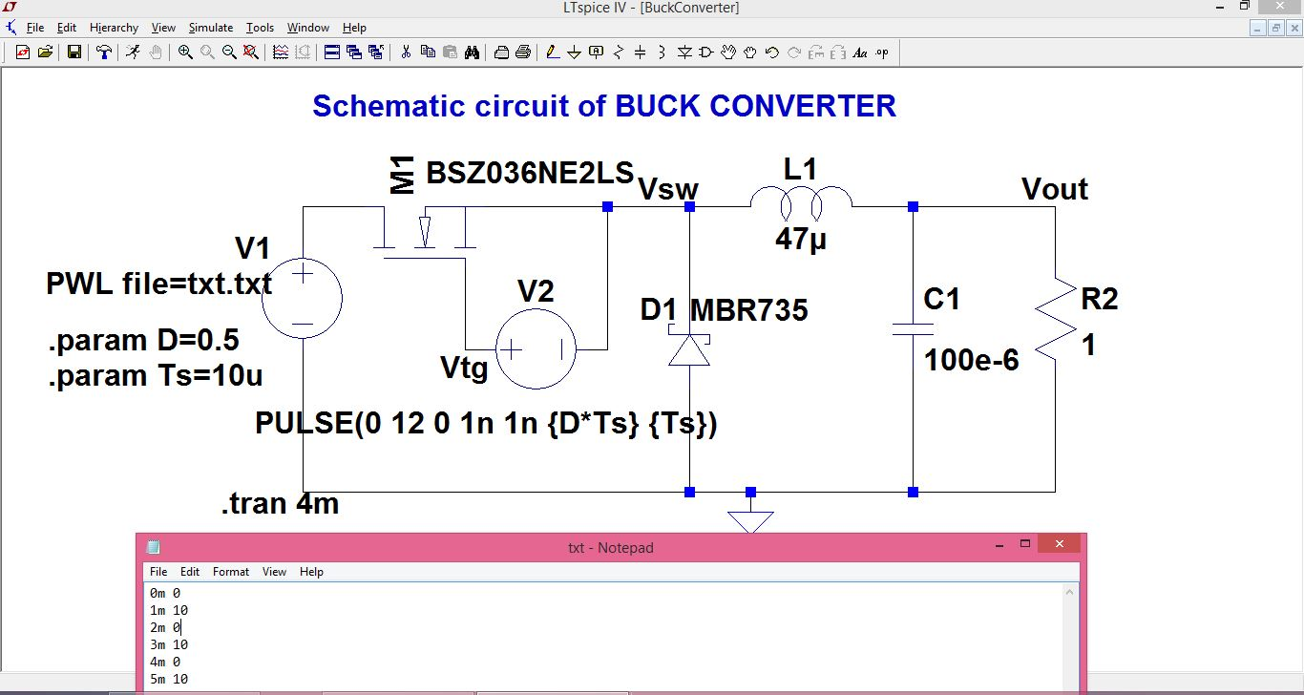
Fig.5
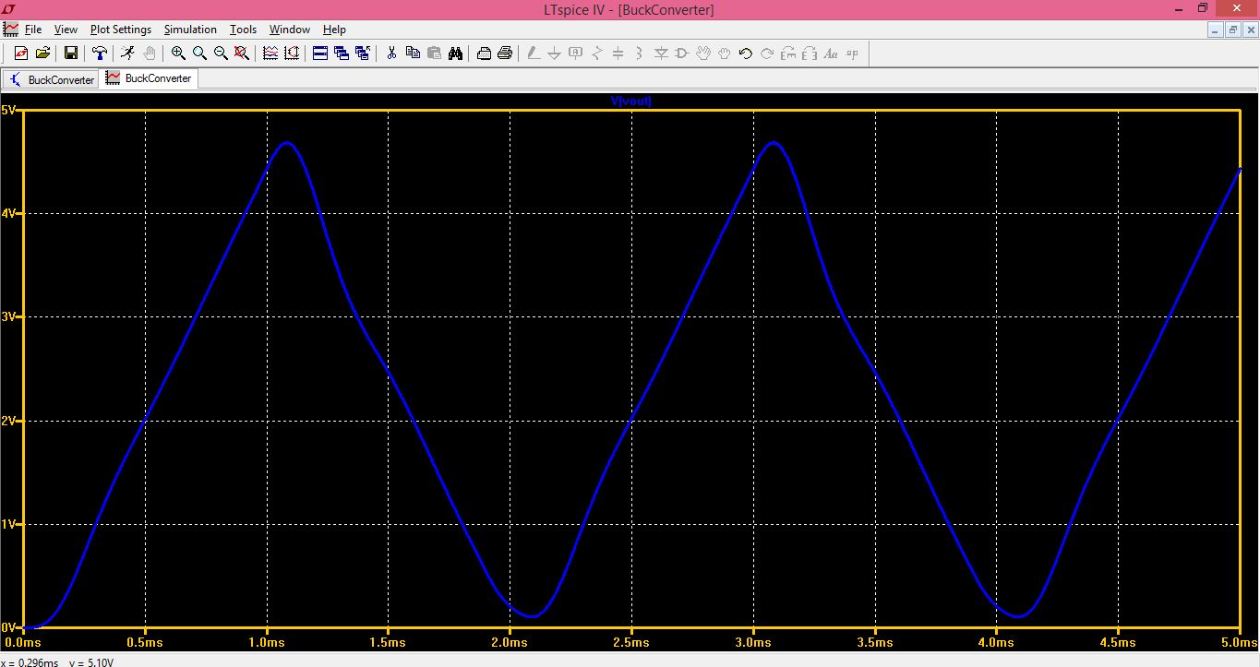
To obtain the PWL waveform, edit the function window for the voltage file and link a notepad window with the desired code to the PWL file browser. The schematic and simulation waveform for the same is Fig.5 and 6 respectively.

Fig.6

